
NAME:

12 ATMAA Test 6 2020 Project Networks

Section 1: / 25

Section 2: / 29

Total: / 54

%

Material required/recommended for this test

To be provided by the supervisor
Question/answer booklets for Sections One and Two.
SCSA 12ATMAA Formulae Sheet

To be provided by the candidate

Section One:

Standard items: pens, pencils, pencil sharpener, highlighter, eraser, ruler
Special materials: drawing instruments, templates, no notes, formula sheet

Section Two:

Standard items: pens, pencils, pencil sharpener, highlighter, eraser, ruler
Special materials: drawing instruments, templates, notes on a maximum of one unfolded sheet of A4 paper, double sided, up to three approved calculators, CAS, graphics, or scientific.

Important note to candidates

No other items may be taken into the test room. It is your responsibility to ensure that you do not have any unauthorised notes or other items of a non-personal nature in the test room. If you have any unauthorised material with you, hand it to the teacher before reading any further.

CALCULATOR FREE

STRUCTURE OF SECTION 1

Section | Number of  questions  available | Number of  questions to  be answered | Working  time  (minutes) | Marks  available | Percentage  of Test
Section One:  Calculator-free | 4 | 4 | 28 min | 25
Section Two:
Calculator-assumed
Total

Question 1 (6 marks)

The weights on the graph below are the costs, in hundreds of dollars, to connect adjacent offices to a new IT system.
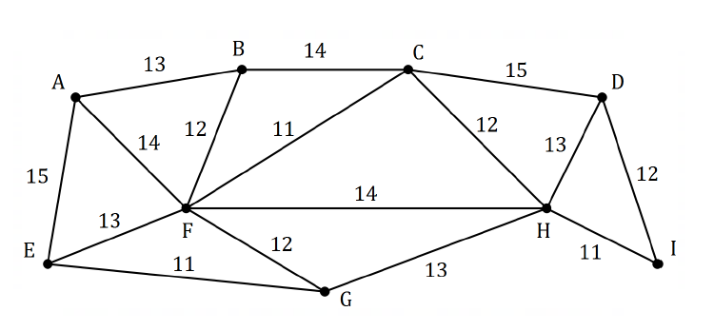

- Cleary indicate the minimum spanning tree on the graph above. (2 marks)

- Determine the cost of connecting the offices to the new IT system using the minimum spanning tree. (2 marks)

- An IT consultant recommends that the new system must include a connection between office 𝐴 and office 𝐵, and between office 𝐴 and office 𝐸. Determine the minimum cost of connecting all the offices using a spanning tree that includes these two edges. (2 marks)

Question 2 (7 marks)

The digraph below shows the possible routes that a car can take to reach freeway entry 𝐹 after they leave carpark 𝐴. The weights on each edge represent the maximum number of cars that can travel between adjacent intersections (vertices) every minute.
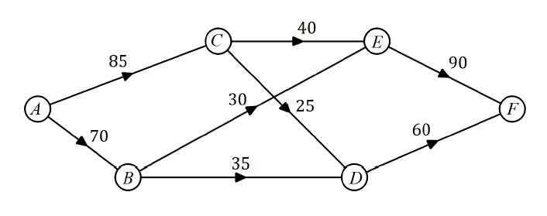
- Determine the maximum number of cars that can travel from 𝐴 to 𝐹 every minute. (3 marks)

- Determine, with justification, the maximum increase in the flow of cars every minute from 𝐴 to 𝐹 that could be achieved by adding a new route

  - from 𝐴 to 𝐷 that can carry up to 40 cars per minute. (2 marks)

  - from 𝐶 to 𝐹 that can carry up to 30 cars per minute. (2 marks)

Question 3 (6 marks)

The network shows a system of pipes with the maximum capacity for each pipe, in litres per second, shown on the edges.

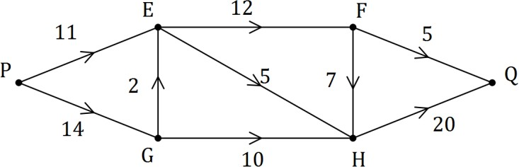

- Cut 𝑋 passes through edges 𝑃𝐸 and 𝑃𝐺, and cut 𝑌 passes through edges 𝐸𝐹, 𝐹𝐻 and 𝐻𝑄. Show these cuts on the network and state the capacity of each. (2 marks)

- Determine the maximum flow through the system from 𝑃 to 𝑄 by listing each path used and the flow along each path. (3 marks)

- Show cut 𝑍 on the network that has capacity equal to the maximum flow. (1 mark)

Question 4 (6 marks)

Three trucks, selected from a choice of four, are to be used to carry sand from a quarry to three building sites. The table below shows the weight of sand that each truck can carry to each site per day.

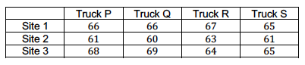

Use the Hungarian algorithm to show that the maximum amount of sand that can be transported to the three sites is 198 tonnes per day and state the required allocation of trucks to achieve this maximum.

Additional working space
Question number:


NAME:

Section 2: /29

12 ATMAA Test 6 2020 Project Networks

CALCULATOR ASSUMED

Show all your working clearly. Your working should be in sufficient detail to allow your answers to be checked readily and for marks to be awarded for reasoning. Incorrect answers given without supporting reasoning cannot be allocated any marks. For any question or part question worth more than two marks, valid working or justification is required to receive full marks. If you repeat any question, ensure that you cancel the answer you do not wish to have marked.

STRUCTURE OF SECTION 2

Section | Number of  questions  available | Number of  questions to  be answered | Working  time  (minutes) | Marks  available | Percentage  of Test
Section One:
Calculator-free
Section Two:  Calculator-assumed | 4 | 4 | 32 min | 29
Total

Question 5 (8 marks)

A project consists of activities 𝐴₁ to 𝐴₁₀. The duration and immediate predecessors for each activity are shown in the table below.

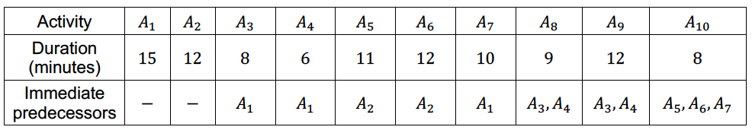

- Complete the network below to represent the durations and interdependencies of all the activities in the project. (2 marks)

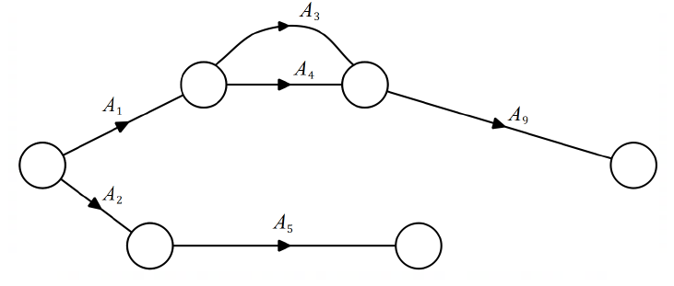

- Determine the earliest starting time for 𝐴₁₀. (1 mark)

- List, in order, the activities that lie on the critical path and state the minimum completion time for the project. (2 marks)

- Determine the latest starting time for 𝐴₅. (1 mark)

- If the duration of 𝐴₅ was increased by 5 minutes, what effect, if any, would this have on the critical path and minimum completion time? (2 marks)

Question 6 (6 marks)

Spectators leave a sports ground 𝐴 and walk to a train station 𝐻 along footpaths in the directions shown on the network below. The weights on the edges represent the maximum number of people who can safely travel along each footpath, in hundreds of people per minute.

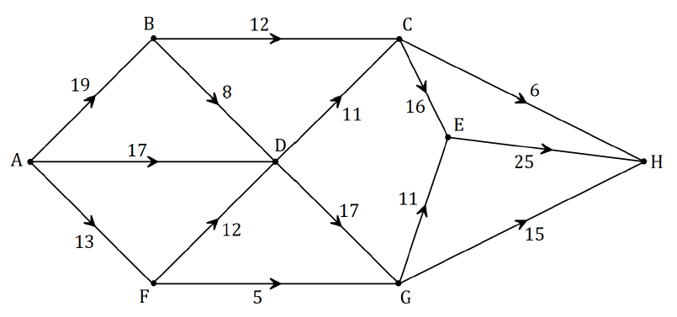

- By listing the different paths and their corresponding flow rates, determine the maximum number of people that can walk through the network from 𝐴 to 𝐻 every minute. (4 marks)

- Verify your answer from part (a) by showing the minimum cut on the network above and showing in the space below how to determine the capacity of the cut. (2 marks)

Question 7 (8 marks)

A school has received quotes from venues A, B, C and D to host teams of students to play knockout competitions in basketball, hockey and volleyball. The four venues can only host one sport at a time and their quotes, in hundreds of dollars, for each sport are shown below.

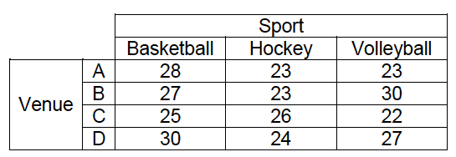

- If venues B, C and D are chosen for basketball, hockey and volleyball respectively, calculate the total cost. (1 mark)

- Represent the choice of venues for each sport as a bipartite graph. (2 marks)

- Show use of the Hungarian algorithm to determine a suitable allocation of sports to venues in order to minimise the total cost and state the minimum cost. (5 marks)

Question 8 (7 marks)
Nathaniel wishes to upgrade his sprinkler system using the least possible length of piping. The weighted graph below shows the existing system. The numbers on the edges indicate the length of each pipe, in metres, between sprinklers A, B, C, D, E, F, G and H.

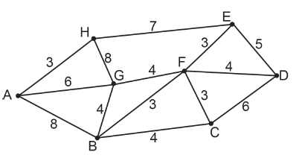

- Complete the table below showing connections between each sprinkler. (2 marks)

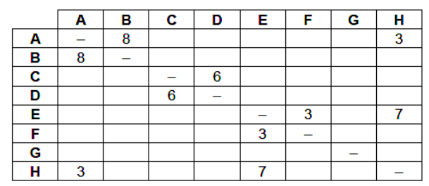

- Show the use of Prim’s algorithm to establish a minimum spanning tree for the least length of piping required. (3 marks)

- Draw this tree on the diagram below. (2 marks)

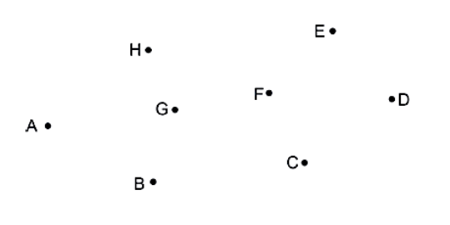
Additional working space
Question number:

